* You should submit this file as answered and ER diagram in zipped folder. Named the folder as ***studentNo1_ studentNo2_ studentNo3_Part1***.
* **Indicate all project members’s student No- Name surname.** One “project part1 submission” from each grup will be enough. There is no need to make submission for each member.
* Your database should consist of at least 5 tables.
* ER diagram should specifiy all entities-relationships-attributes. Send it as a file (.pdf, jpg..). Online ER diagram tools or programs (ex: dia,visio…) can be used.
* Copy homeworks will be evaluated as 0.
* Late submissions are not allowed.
* Use Google Classroom for your questions.

**Group members:**

|  |  |  |  |
| --- | --- | --- | --- |
| **Group No** | **Student ID** | **Name** | **Project Topic** |
|  |  |  |  |
|  |  |
|  |  |

**1:** What is the purpose of your project? Explain.

**2:** Draw your E-R diagram (Specifiy all entities-relationships-attributes). Send it as a separate file (.pdf, jpg..). Show (explain in detail) that the database is at least in 3rd NF.

**3:** Explain your tables and attributes of tables. Explain your data types of attributes of tables. Why you choose that type?

For example: “I used an ***char*** type for the attribute **Ssn (Social security number)** because … ”

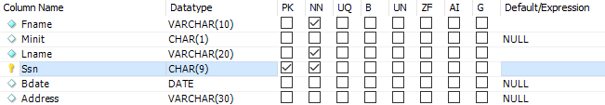

**4:** Define your primary and foreign keys. Why they are keys? Explain.